Unexpected variance from Octave for Gaussian distribution

I generated a 3*3 kernel using with variance 1 with this command:
> G = fspecial('gaussian', [3 3], 1);
I expected the variance of G must be “1”, because I use 1 as value of in "fspecial" command. But result of "var(G(:))" in Octave is "1.8117e-03". Which is far from "1". I think the problem is in about being discrete; because Gaussian is continuous.

Then I tried manually simulating for 1D:
> X=linspace(-3,3,10000);
> Y=(1/sqrt(2*pi)*e.^(-(X.^2/2)));
> var(Y)
ans = 0.019389
Also this result is far from "1" too.

I asked this question about this problem: https://math.stackexchange.com/q/4624650/21779

G = fspecial('gaussian', [10 1], 1);
plot(G);

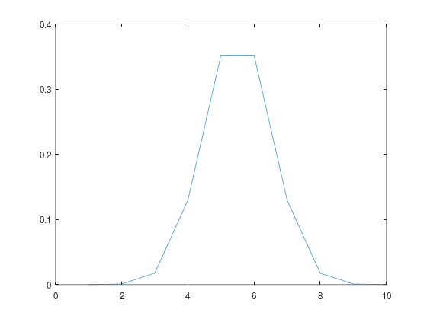

G = fspecial('gaussian', [100 1], 1);
plot(G);
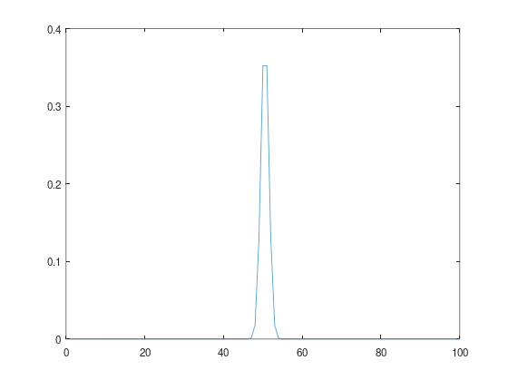

Solution

My idea was:
I think when I have a PDF, then variance of {PDF(x_i)} for enough number of x_is will be close to the variance of PDF.

But that is not correct. Misunderstanding causes the problem. Note that:

µ = E[X] = \int_{-\infty}^{\infty}{x f(x) dx}
σ² = Var(X) = E[(X-\mu)^2] = \int_{-\infty}^{\infty}{(x-\mu)^2 f(x) dx}
Also:
Var(X) = E[(X-\mu)^2] = E[X^2] - (E[X])^2

As you can see, both are defined based on integral and depend on both X (random variable) and f(x) (which we know it as PDF). As those are based on integral, in a discrete case, we hae approximate the integral by Riemann sum approximation.

As we know µ of Gaussian kernel is 0, so in our case:
Var(X) = E[X^2]
For range [-3,3] which is parted to 10000 pieces, Δ must be 6/10000. We can write a “.m” file to evaluate
\sigma\limits_{i=1}^{10000} X^2 f(x) \frac{6}{10000}
Or equivalently:
6 * \sigma\limits_{i=1}^{10000} X^2 f(x) \frac{1}{10000}
Above \sigma is the average for X^2 f(x) for 10000 points. Hence the variance is 6 times the result of \sigma. So in Octave we can use this:
v = 6 * mean (X.^2.*Y)
ans = 0.9706

Further more, if you use [-10,10] and split it to 100 parts, the result will be more closer:

> X=linspace(-10,10,100);
> Y=(1/sqrt(2*pi)*e.^(-(X.^2/2)));
> 20* mean(X.^2.*Y)
ans = 0.9900

This link helped me:
https://stats.stackexchange.com/q/133465

